**Design work**

Multimedia team

Contents

Overview 2

**Diagrams** 2

Resource Manager 2

Game Objects 3

Particle System 4

**U**I **Mocks** 5

Player (Vessel) View 5

Player (Deity) VIEW 6

Spectator (Ghost) View 7

# Overview

This document contains all flow diagrams, pseudocode, class structures, and any other design related assets created by the multimedia team. These diagrams have been separated from the work breakdown for clarity.

# **Diagrams**

## Resource Manager

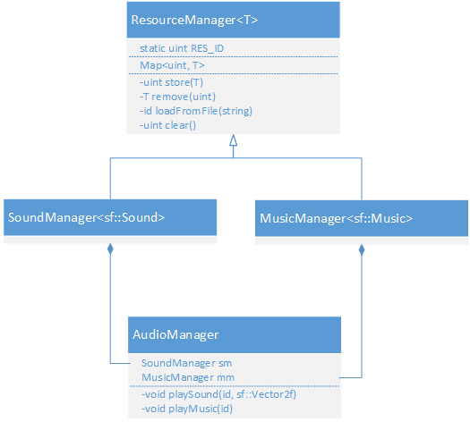

## Game Objects

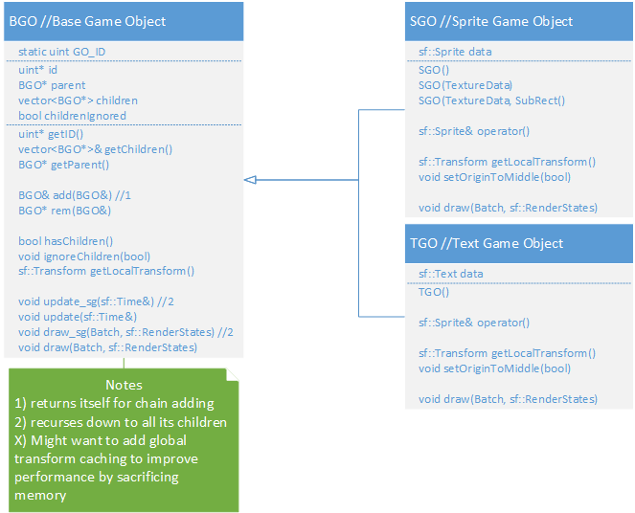

## Particle System

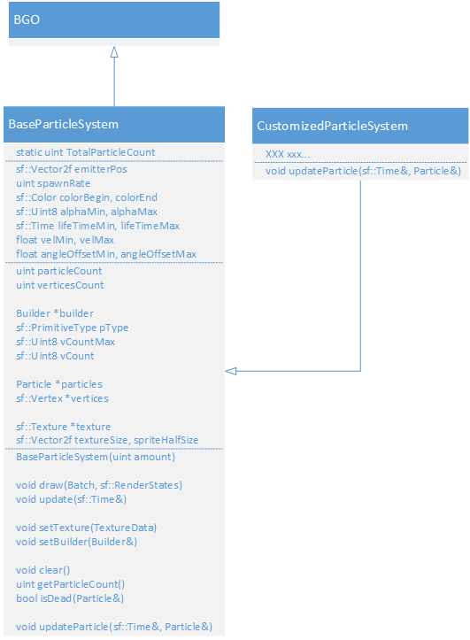

# **U**I **Mocks**

## Player (Vessel) View

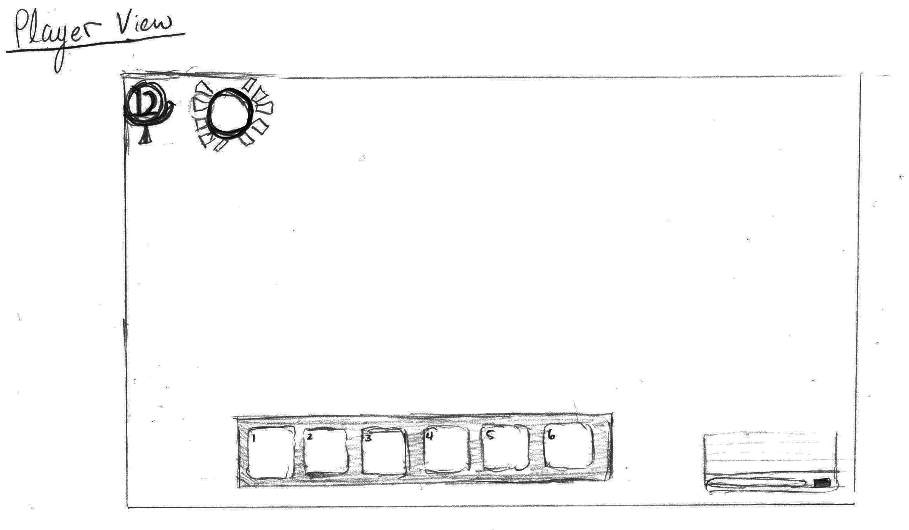

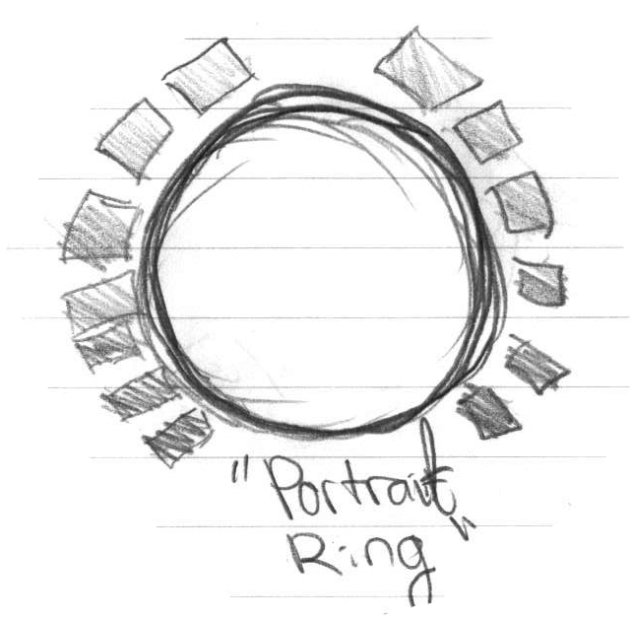

**Includes:**

1. Health bar surrounding an up-scaled icon of the player’s mask
2. level indicator
3. skill bar
4. transparent chat box in bottom left that fades out when inactive

* The experience bar will not be visible to the player except when a kill is made. It will appear as a simple golden bar above the players head for a brief period of time.
* No timer is displayed to the player (at this point)
* Mini map is not visible
* Scores will *only* be visible at the end of each round/match in the form of a scoreboard
* stats and weapon info are not available to the player (not necessary; only one weapon per class in game and stats are not chosen by the player)
* status effects will be visible on the sprite itself therefore no indicators GUI-wise

## Player (Deity) View

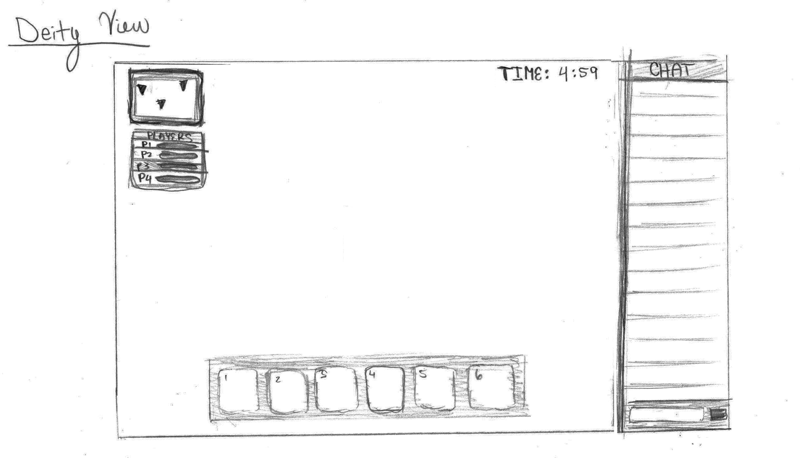

**Includes:**

1. mini map with player markings
2. player selection box with basic HP bar for each player; clicking on a player will bring the deity to that player’s view
3. timer counting down
4. chat box
5. skill bar

## Spectator (Ghost) View

This view is identical to the deity view minus the skill bar. Upon a vessel’s death, the chat box will grow upwards and become present. The skill bar will vanish and the HP / level indicators will be swapped for the mini map.